Practical-5
Practical Title: Registration Form with Frontend Validation and User-Friendly Error Handling
Problem Definition: Create a student registration form with HTML5 input types and JavaScript validation for name, email, mobile number, password, confirm password, course, year, gender, and terms acceptance. Use Regular Expression for validations.

A.Theory:
1. Are correct input types and attributes used?
Answer: Yes.
2. Are validation errors displayed near the relevant fields?
Answer: Yes.
3. Is password strength checked?
Answer: No.
4. Is the form accessible using keyboard and screen-reader-friendly
labels?
Answer: Yes.

B.Implementation/ Output/Result
In this practical, regular expressions were used by me to validate the inputs on both the login and registration pages. On the login page, a pattern was written for the college ID, and a password pattern was applied to check the minimum length and character rules before the form is submitted. On the registration page, the same college ID pattern was used, along with a strong password pattern (minimum 8 characters with at least one uppercase letter, one lowercase letter, one digit and one special character, checked using lookahead assertions), and the confirm password field was compared with the password field to make sure both values match.
C.Evidence Of Work(Screenshots):
1)Login Page:
All Fields are Valid:
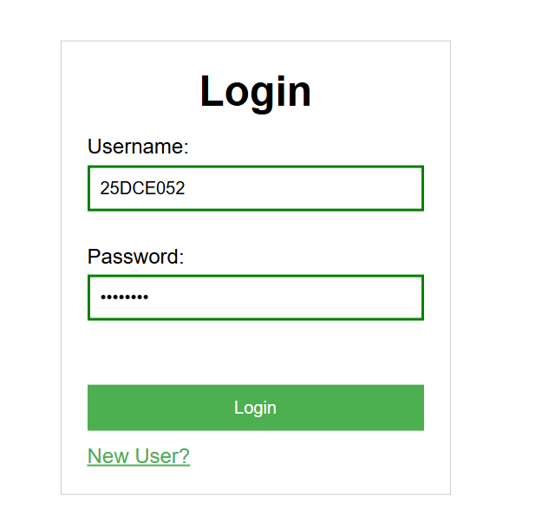

Invalid Fields:
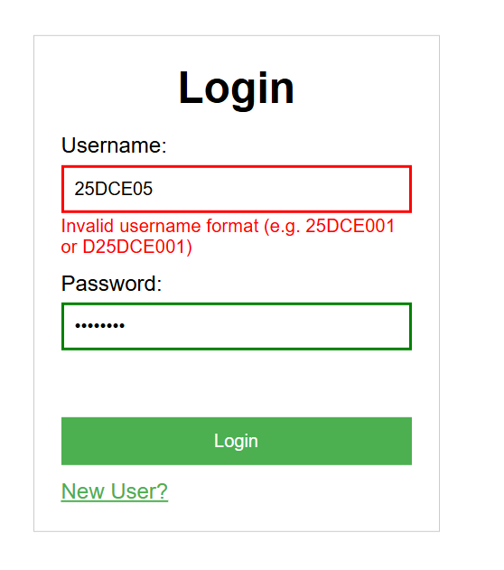

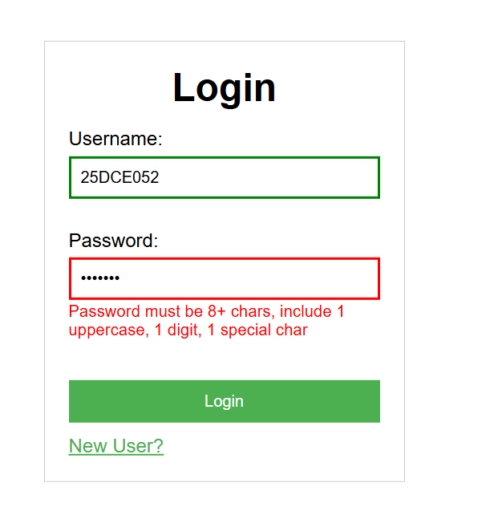

2)Register Page:
All Valid Fields:
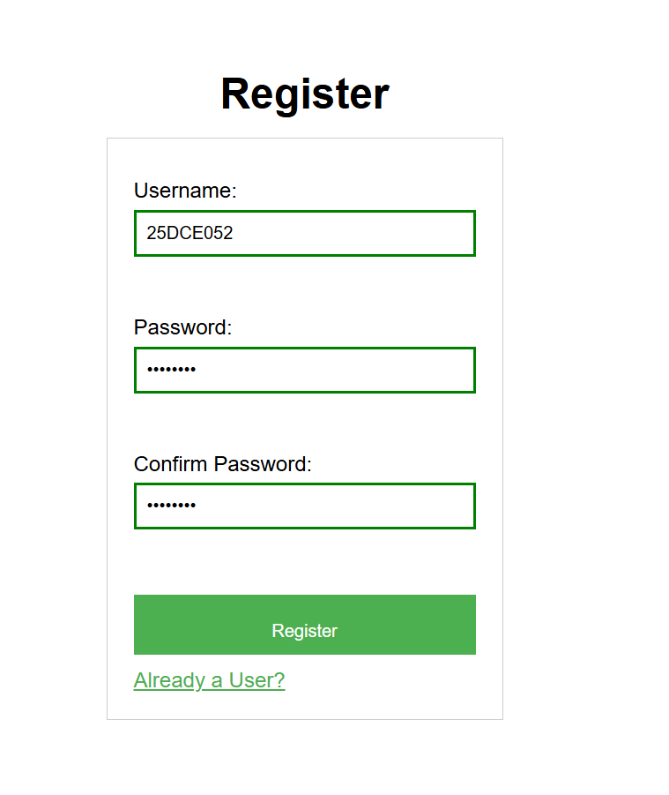

Invalid Fields:
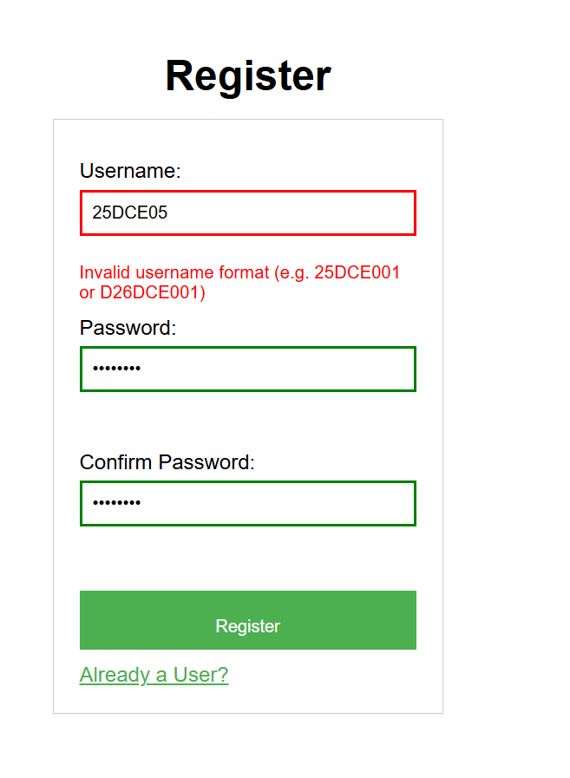

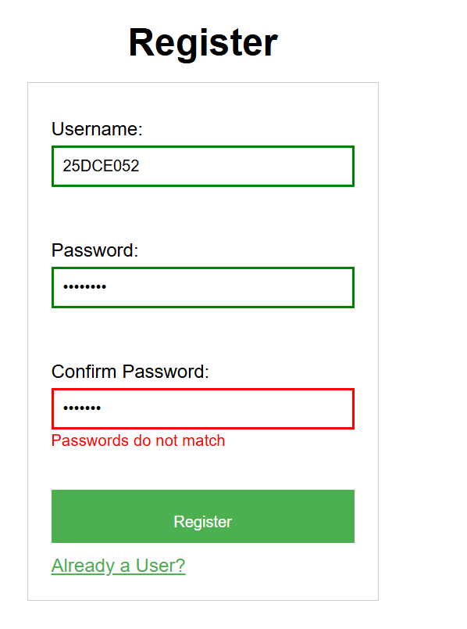
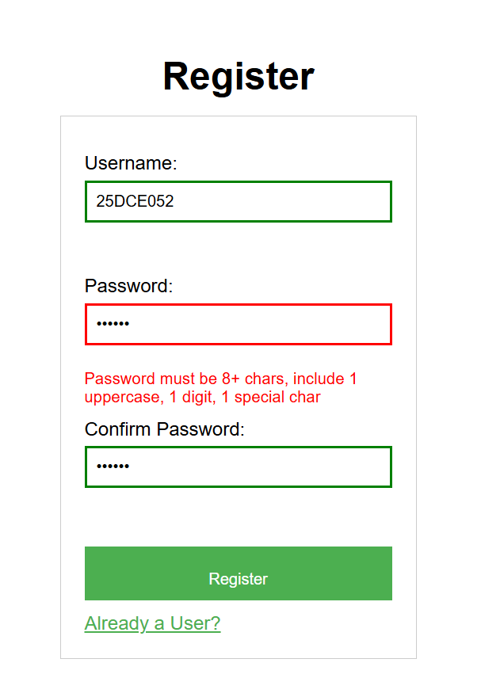

D. GitHub Repository Link: https://github.com/HimeshMale/Student-Hub-Portal.git

E. Challenge Faced:
A common challenge was trying to find correct Regular Expression for College ID and Password .

F. Learning Outcomes:
Through this practical, I learned how to validate the login page and registration page using Regular Expression. How to find correct Regular Expression for different patterns in strings.
Faculty Remarks:

